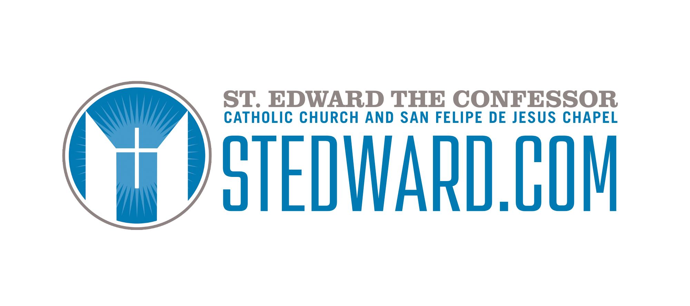

Confirmation Year 1 and Year 2 Service Project Hours:

- Get involved by giving back to your Parish community through service and presence.
- Contact the person you need to begin your service hours. (contact info below each ministry)
- You need 15 hours PER YEAR of Confirmation.
- 7.5 hours at St. Ed’s + 7.5 hours outside in the community.

Usher Ministry
Location: Church Building During Mass
Hours given: 1 Hour of service given per Mass

The Usher Ministry provides hospitality, comfort and safety at the Masses and other special liturgies.
Ushers foster a sense of community, take up the collection, distribute bulletins, assist in emergencies and provide information.
We are seeking Responsible, Reliable volunteers to be an example of Christ’s love and witness to our community.
*Note: Minor teens must be accompanied by a parent or guardian when serving. And parent/guardian must be a registered parishioner.
If interested, please complete an Usher Application -providing both parent/guardian and minor’s information. (You can ask any Usher to provide one of these to you) and return it to the front office.

Please contact: Mary Ann Wilkinson at DrMaWilkinson@gmail.com

Host a teen Bible study 1/ month

Opportunity: 1/month
Hours given: 3 hours per Bible study

Do you enjoy Bible studies? Have you ever thought of hosting one? You would be responsible for creating a flier to get the word out and invite other high school teens to attend, coordinating dinner and snacks and drinks, plus working with Ms. Diana on the Scripture to be read and studied that night.

We would love to create the space here for St. Ed’s youth room for you to lead a youth-led Bible study at our Encounter youth group 1/month.

Please contact: Miss Diana if interested: dwehbe@stedward.com

Media Ministry

Location: Church
During the 5:30pm Sunday Teen Mass
Hours given: 1 hour per Mass
My name is Gloria and I assist with the Media and Livestream at St. Edward. Media is a behind-the-scenes evangelization opportunity for teens at Mass. Media involves progressing the slides for Mass participation or operating the livestream. Both options require training unless you have assisted before. Aside from training, volunteers must arrive 15 minutes early to assist their regularly scheduled Mass and serve when available. We always welcome additional members to join and will be glad to train you.
Please contact Gloria Turnbull at gturnbull@stedward.com
SEEK Middle School Ministry
Location: St. Ed’s Youth Room
Hours Given: 2 hours every other Tuesday of the month

SEEK Middle school ministry meets every other Tuesday of the month 5:30-7pm.
SEEK provides a faith-filled and fun experience of Catholic fellowship for middle school teens.
We are seeking reliable and outgoing high school teen volunteers to work with our middle school students as youth mentors! You will play games with them and lead them in faithful conversations in small groups.

If you are interested, please contact Ms. Diana Wehbe dwehbe@stedward.com

Teen Mass Choir (5:30pm Sundays)
Location: Church
Every Sunday 5:30pm Mass
Hours given: 2 hours/week

Can you sing? Or play an instrument? Come audition with our Director for Contemporary Music, Johnny Oskam and see if this teen Mass choir is the right fit for you!

If interested reach out to Johnny JOskam@stedward.com

Altar Server
Location: In the Church
Dates: Weekly at Masses
Hours Given: 1 hour/Mass served

Have you seen those young people on the Altar with Father wearing the white Albs? Those are Altar servers. Would you like to train to serve on the Altar of Jesus?

If so, contact Karen Finnigan (617) 721-1712 or Ktkelmo@aol.com

Bring food for Encounter or Seek (year round)
3 hours given for each sign-up
What to bring: dinner, drinks and dessert for 10 teens + attending the ministry.

Links to sign up for this can be obtained by emailing Miss Diana at dwehbe@stedward.com

Lectors
Location: in the Church
Date: Sunday 5:30pm Mass
Hours Given: 1 Hour/Sunday that you read

Hello, my name is Jackie Brady, and I help train and schedule lectors for the Saturday evening and Sunday Masses. We would love to have you help serve your parish as a lector! You are welcome to be a lector at any Mass, but particularly we would like you for the Sunday 5:30 Mass. Lectors serve about 1x per month. You do have the ability to request specific dates and times and to tell us your availability so we schedule you at a date and time that works for you and your family. Training is approximately one hour, and we will work with you to schedule it at a convenient time. If you have any questions at all, please do not hesitate to call or text me.
Thank you for volunteering!

If interested: Jackie Brady (949) 391-6152

Night to Shine
Location: Knight Hall
Dates: February 5th, 2027 (plus additional dates for training tbd)
Hours: 15
Hi, my name is Stephanie Baren and Night to Shine (“NTS”) is a worldwide prom night experience sponsored by the Tim Tebow Foundation for special needs guests ages 14 and older. Night to Shine 2026 will be held on Friday, February 13th at the Parish Center. This ministry has lots of volunteer opportunities for teens:
Teen Planning Committee Member: We have a few spots open for teens looking to join our planning committee. We will begin meeting once a month in July. Our summer meetings will be held at my home in San Clemente. Once school begins, meetings will most likely be one Sunday a month at 2pm at the Parish Center. This year, our group of teens will be focused on brainstorming, planning and implementing fundraising events as well as marketing. Those who are interested please email me at stedsnts@gmail.com.
Day of Event Opportunities:
There will be lots of teen volunteer positions for the Night to Shine event, specifically: (1) set up crew, (2) food server, (3) interactive stations (e.g.,flower station, Photo Booth, limo rides, make-up/accessories, shoeshine) and (4) Guest Buddy. The Guest Buddy role is reserved for those teens with experience with special needs or who feel comfortable partaking in the entire evening one-on-one with a special guest of the same gender.
A signup link will be sent out in early December with limited spots for each volunteer role. Volunteers are also required to attend a two hour training session the week prior to NTS. Service hours are awarded for the training session as well.
We sincerely hope you will join us in creating this magical night for those with special needs in our community!

Contact Stephanie Baren stedsnts@gmail.com

Children’s Faith Formation + Parish Life events:
Location: Parish Center/ Knight Hall
Dates: (several opportunities throughout the year)
Hours given: Dependent on how many hours you serve

- Clean patio chairs and tables (Mikie) date as convenient
- Catechist aides during Faith Formation classes Sundays 10:15 to 11:30
- September 25 Movie Night The Reluctant Saint 6:30 to 8:30pm
- Sweets for Saints (dressing up as a Saint and being in character to help support this event) on October 31 5pm to 8:30pm
- November 21 Presentation of Mary Procession /Mass 8:00am -9:00am
- November 28 Tree Lighting/ADVENT RETREAT 5:00 - 8:30pm Church/Plaza
- December 8 Immaculate Conception Day of Obligation snack & Craft 5:00 - 7:00pm
- Retreat guides for Reconciliation retreat April 18 9:30am-12:45pm and 1st Communion Retreat May 15 8:30 to 1:30pm
- February 2 Presentation of the Lord Procession /Mass 5:00 - 6:15pm Church May 6 Ascencion of the Lord Holy Day of Obligation snack & Craft 5:00 - 7:00pm
- VBS (summer 2027)

If interested contact Lupe Ojeda: Lojeda@stedward.com

Catholic Charities Fashion Show Benefit
Location: Knight Hall
Date: Date February 6th 2027
Hours Given: 15

Catholic Charities puts on an annual fashion show here at St. Ed’s to raise funds to help with charitable causes in our Church. This year the funds went to counseling programs for children in need. For this event, you will help SET-UP and CLEAN-UP and maybe even walk down the runway!
And you will assist at one of the booths for the fashion show or you will volunteer to model, MC etc.
Plan to be there from 8am-3pm

If interested contact: Darlene Jamroz Darjamroz4realestate@gmail.com

Building A Miracle
15 hours for the build + assisting at the promo tables after Masses

Confirmation candidates seeking service hours are invited to participate in Build A Miracle, a meaningful opportunity to serve alongside the St. Edward the Confessor community. For the second year in a row, our parish and school community will come together this fall to raise funds to build a home for a deserving family in Tijuana. After the new year, we will complete the project through three Build A Miracle Mission Days (dates TBD in early 2027), with each trip providing approximately 8–10 hours of service that may be applied toward Confirmation service requirements. All family members are welcome to participate, making this a wonderful opportunity to serve together while making a lasting difference in the lives of another family. A SignUpGenius with trip dates and registration information will be distributed once details are finalized.

Contact Sylvia Palda for more info: (949) 244-5781

Kids around the world packing day
October 9th 2027

This annual food packing event happens here at St. Ed’s and last year we packed 50,000 meals for hungry children in Uganda.

If you’d like to take part this year information will be sent out regarding date and time and hours given when the event is closer to occurring.
If interested contact Dara Sandrini: darasandrini@gmail.com

